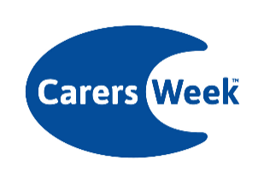Carers Week 2025 supporter pack

Social media suggested copy

🗓️ Save the date #CarersWeek 2025!
This year’s theme is Caring About Equality and from 9-15 June we will be joining the call for greater equality for unpaid carers.
Find out more here 👉 www.carersweek.org
--
There are lots of ways to get involved in #CarersWeek! Visit www.carersweek.org to find out more about how you can take part in loads of great activities and help call for greater equality for unpaid carers.
--
We’re proud to be supporting #CarersWeek and helping call for greater equality for unpaid carers.
Find out more here 👉 www.carersweek.org
--
🗓️ Save the date #CarersWeek 2025!
This year’s theme is Caring About Equality and from 9-15 June we will be and joining the call for greater equality for unpaid carers.
Together let’s work towards an equal society, where carers are truly valued, recognised and supported.
Get involved with Carers Week 2025, find out more here 👉 www.carersweek.org
--
Graphics can be downloaded here: Carers Week 2025

